**JAVA SCRIPT**

**COMPILER VS INTERPRETER**

1. **Compiler:**
   * A compiler translates the entire source code of a program into machine code or an intermediate language before execution.
   * It scans the entire code, checks for syntax errors, and generates an output file (executable or intermediate code) without executing it.
   * The generated output is independent of the source code and can be executed multiple times without recompilation.
   * Compilers typically produce faster and more optimized code because they have more time to analyze and optimize the entire program.
   * Examples of compiled languages include C, C++, and Java (which is compiled to bytecode).
   * A compiler translates the entire source code of a program written in a high-level programming language (like C, C++, Java) into machine code or another lower-level language (like bytecode in the case of Java). This translation process produces an executable file or an intermediate representation that can be executed directly by the computer's hardware or a virtual machine.
2. **Interpreter:**
   * An interpreter processes code line by line, executing each line immediately after it's translated from source code to machine code or an intermediate representation.
   * It reads and executes the source code directly, translating and executing it on the fly.
   * Interpreters are slower than compilers because they don't perform extensive analysis and optimization upfront. They analyze and execute code simultaneously, which can result in slower execution.
   * The interpreter needs to be present on the system where the code runs because it's responsible for executing the source code.
   * Examples of interpreted languages include JavaScript, Python, and Ruby.
   * An interpreter, on the other hand, translates and executes the source code line by line during runtime. It doesn't produce an independent executable file. Instead, it directly reads the source code, translates it into machine code or an intermediate representation, and executes it immediately. This means that the source code needs to be present on the system where the program is executed, and the interpreter is responsible for the execution process.

In summary, while both compilers and interpreters translate high-level code into machine code or an intermediate form, compilers do so before execution, while interpreters do so during execution. Each approach has its advantages and disadvantages, leading to different performance characteristics and usage scenarios.

**API**

An **API** (Application Programming Interface) acts as a communication medium/messenger between two programs or systems/ applications or software components. It defines a set of rules and specifications for how these parts can communicate and exchange data. Here’s how it works:

* **Client and Server**:
  + The **client** (user/device) sends a request to the **server** (backend).
  + The server processes the request and provides a response.
* **Request and Response:**
* **The Request:**

When a developer wants to use an API, they send a request to the API server. This request typically includes information about the action they want to perform, such as retrieving data, updating records, or executing a function.

This request usually specifies:

* **Endpoint:** The specific part of the API the client wants to interact with. Imagine an endpoint like a department in a large company; it handles specific tasks.
* **Method:** The type of operation the client wants to perform. This could be getting data (GET), creating data (POST), updating data (PUT), or deleting data (DELETE).
* **Data (Optional):** Depending on the method, the request might include data to be sent to the server (e.g., for creating or updating data).

The API server receives the request, processes it according to the API's specifications, and generates a response. The response contains the requested data or indicates the success or failure of the requested operation.

* **The Response:**

Once processing is complete, the server sends a response back to the client. This response usually includes:

* + **Status Code:** A code indicating the success or failure of the request. Common codes include 200 (OK) for success, 404 (Not Found) if the requested resource doesn't exist, or 500 (Internal Server Error) if something went wrong on the server's side.
  + **Data (Optional):** If the request was successful, the response might contain data returned by the server. This could be formatted in various ways like JSON (JavaScript Object Notation), XML (Extensible Markup Language), or plain text.
* **Communication Protocol:**
  + APIs use different communication protocols to transmit data between the client (the software making the request) and the server (the software providing the API). Common protocols include HTTP, HTTPS, REST, SOAP, and Graph-QL
  + APIs on the web use the **HTTP protocol** (Hyper Text Transfer Protocol).
  + The communication follows a **request-response cycle**:
    - Client sends a request with:
      * **URL**: Web address for the request.
      * **Method**: Retrieve existing data or save new data.
    - Server responds based on the request.
* **Example**:
  + Suppose you search for nature photos on Unsplash.
  + Behind the scenes, an API handles the conversation:
    - You (client) request nature photos.
    - Unsplash (server) responds with a list of photos.

Remember, APIs enable seamless data sharing between applications!

* **Authentication and Authorization:**
  + Many APIs require authentication to ensure that only authorized users or applications can access their resources. Authentication mechanisms vary and may include API keys, OAuth tokens, JWT (JSON Web Tokens), or other methods.
  + After authenticating the request, the API server checks whether the authenticated user or application has the necessary permissions (authorization) to perform the requested action. If authorized, the server processes the request; otherwise, it returns an error response.
* **Data Formats:**
  + APIs use standardized data formats such as JSON (JavaScript Object Notation) or XML (eXtensible Markup Language) to represent the data being transmitted between the client and server.
  + JSON has become the de facto standard for data exchange in modern APIs due to its simplicity, readability, and compatibility with multiple programming languages.

In summary, APIs facilitate communication between software systems by defining rules and protocols for exchanging data. Developers use APIs to access the functionality provided by other software services or platforms, enabling integration, automation, and interoperability between different applications.

**JavaScript is often referred to as both a scripting language and a programming language, and it can be considered as both, depending on the context.**

1. **Scripting Language:** Think of JavaScript as a tool you use to write small programs (scripts) that tell your web browser how to behave. It's like giving your browser a set of instructions to follow, like changing colors or showing pop-up messages.
2. **Programming Language:** JavaScript can also be seen as a language for building more complex software, like applications or games that run inside your browser. It's like using a language to build something big and sophisticated, not just simple instructions.

It can do simple tasks (scripting) and complex ones (programming) depending on what you need it to do on the web.

**JavaScript execution in web browsers**

1. **Parsing:** When a web page is loaded, the browser's HTML parser encounters a **<script>** tag containing JavaScript code. The browser then starts parsing and interpreting the JavaScript code line by line.
2. **Lexical Analysis:** The JavaScript engine breaks down the code into individual tokens (keywords, identifiers, operators, etc.) during lexical analysis.
3. **Parsing:** The engine then parses these tokens into a data structure known as the Abstract Syntax Tree (AST), which represents the syntactic structure of the code.
4. **Compilation/Interpretation:** Depending on the browser and engine, the JavaScript code may be compiled or interpreted. Modern engines like V8 (used in Chrome) and Spider-Monkey (used in Firefox), Chakra was the JavaScript engine used in older versions of the Edge browser. However, Microsoft Edge now uses the Chromium engine, which includes the V8 JavaScript engine. typically use a combination of techniques including Just-In-Time (JIT) compilation to optimize code execution.
5. **Execution:** The optimized code is executed by the JavaScript engine. This involves allocating memory for variables and objects, executing statements, and performing any necessary operations, such as arithmetic calculations, function calls, and DOM manipulation.
6. **Event Loop:** JavaScript execution in the browser is single-threaded, meaning only one task can be executed at a time. To handle asynchronous tasks like fetching data from servers or responding to user input without blocking the main thread, browsers use an event loop. The event loop continuously checks the execution stack for tasks to execute and processes them in a queue-based manner.
7. **Rendering:** As JavaScript code executes, it may manipulate the Document Object Model (DOM) and modify the web page's structure and content. These changes trigger reflows and repaints, which update the visual representation of the page in the browser window.

Overall, JavaScript execution in web browsers involves a combination of parsing, compilation/interpretation, and execution, along with event handling and DOM manipulation to create dynamic and interactive web pages.

**FEATURES:**

1. **Single Threaded:**
   * Single-threaded refers to the execution model where a program or process only has one sequence of instructions (thread) that it can execute at a time.
   * In a single-threaded environment, tasks are performed sequentially, one after another, without parallelism or concurrency.
   * JavaScript in web browsers follows a single-threaded execution model, meaning that JavaScript code is executed sequentially, one statement at a time, without parallel processing.
2. **Dynamically Typed:**
   * Dynamically typed refers to the way variables are handled in a programming language, specifically whether variable types are checked at compile time or runtime.
   * In a dynamically typed language, variable types are not explicitly declared, and they can change during the execution of the program.
   * JavaScript is dynamically typed, which means you don't have to specify the data type of a variable when declaring it. The type of the variable is determined dynamically at runtime based on the type of value it holds.
   * For example, you can assign a number to a variable and later assign a string to the same variable without explicitly changing its type.
3. **Queue (FIFO - First In, First Out):**

* A queue is a linear data structure that follows a First-In-First-Out (FIFO) principle.
* Imagine a line at a store; the first person in line (enqueued) is the first one served (dequeued).
* Elements are added at the rear and removed from the front.

1. **Stack (LIFO - Last In, First Out):**

* A stack is another linear data structure that follows a Last-In-First-Out (LIFO) principle.
* Think of a stack of plates; the last plate added (pushed) is the first one removed (popped).
* Stacks are commonly used for function call stacks, implementing undo/redo functionality, and expression evaluation.
* Elements are added and removed from the top.
* Imagine a stack of plates—you add a plate on top and remove the topmost plate.

**Common features in programming languages:**

Programming languages vary widely in terms of syntax, features, and capabilities, but there are several common features that many programming languages share:

**Basic Building Blocks:**

1. **Variables:**
   * Most programming languages allow developers to declare variables to store data. These variables can hold different types of data, such as integers, floating-point numbers, strings, booleans, arrays, and objects.
   * Named containers that store data of a specific type (like numbers, text, or booleans).
2. **Data Types:**
   * Define the kind of data a variable can hold. Common types include integers, floats, strings, booleans, and arrays (collections of items).
3. **Operators:**
   * Programming languages provide operators for performing arithmetic operations (addition, subtraction, multiplication, division), comparison operations (equal to, not equal to, greater than, less than), logical operations (AND, OR, NOT), and more.
   * Symbols used to perform operations on data (e.g., arithmetic operators like +, -, *, / for calculations, comparison operators like ==, != for comparisons).
4. **Expressions:**

* Combinations of variables, operators, and values that evaluate to a single result.

1. **Control flow:**
   * **Conditional statements:** Allow code execution to branch based on certain conditions (e.g., if statements, switch statements).
   * Control structures enable developers to control the flow of execution in a program. Common control structures include conditional statements (if, else if, else), loops (for, while, do-while), and switch statements.
   * **Loops:** Repetitive execution of a block of code a certain number of times or until a condition is met (e.g., for loops, while loops).
2. **Functions/Methods:**
   * Functions (also known as methods or procedures) allow developers to encapsulate reusable blocks of code. Functions can accept parameters (inputs) and return values (outputs), making code modular and easier to maintain.
3. **Data Structures:**

* Organized ways to store and manage collections of data. Common data structures include arrays (ordered lists), lists (flexible ordered collections), dictionaries/maps (unordered collections with key-value pairs), and sets (unordered collections of unique elements).

1. **Input/Output (I/O):**
   * Most programming languages provide facilities for input/output operations, allowing programs to interact with users through text input/output, file handling, network communication, and other forms of I/O.

**Other Common Features:**

1. **Error Handling:**
   * Programming languages typically provide mechanisms for error handling, allowing developers to catch and handle exceptions or errors that occur during program execution. This helps prevent crashes and ensures more robust and reliable software.
2. **Comments and Documentation:**
   * Comments allow developers to add explanatory notes within the code, making it easier to understand and maintain. Some programming languages also support documentation features that generate documentation from code comments.
3. **Memory Management:**

* How the language manages memory allocation and deallocation for variables and data structures. This can be automatic (garbage collection) or manual.

1. **Modularity and Reusability:**
   * Programming languages support modularity and reusability by allowing developers to organize code into separate modules or libraries. This facilitates code reuse and makes it easier to manage large and complex software projects.

These are some of the common features found in programming languages, but the specific features and syntax may vary depending on the language. Different languages are designed for different purposes and have different strengths and weaknesses, so it's essential to choose the right language for the task at hand.

**JAVA SCRIPT**

What is javascript?

JavaScript is a high-level, interpreted programming language. It's often referred to as a single threaded synchronous, scripting language because it's typically used to write scripts that are embedded in or included from HTML pages and interact with the Document Object Model (DOM) of the web browser. JavaScript is a dynamic, prototype-based language with first-class functions, meaning functions are treated as first-class citizens, allowing them to be assigned to variables, passed as arguments, and returned from other functions.

JavaScript is indeed a high-level, interpreted programming language. Let's break down the key points:

1. High-level: JavaScript is designed to be easy to read and write, abstracting away low-level details and providing developers with a more intuitive syntax.

2. Interpreted: JavaScript code is executed line by line by an interpreter, rather than being compiled into machine code before execution. This allows for rapid development and easy debugging but may result in slightly slower performance compared to compiled languages.

3. Scripting Language: JavaScript is often used for scripting tasks, especially within web development. It's commonly embedded within HTML pages and executed by web browsers to provide dynamic and interactive functionality.

4. Document Object Model (DOM)/ Browser Object Model (BOM): JavaScript interacts with the DOM, which represents the structure of HTML documents as a tree of objects. This allows JavaScript to manipulate the content, structure, and style of web pages dynamically, enabling interactivity and responsiveness. Browser Object Model (BOM) in JavaScript provides access to browser-related features like controlling windows, manipulating the document (web page), navigating browser history, and retrieving information about the user's screen and browser environment. It enables JavaScript to interact with the browser itself, beyond just the content of web pages.

5. Dynamic and Prototype-based: JavaScript is dynamically typed, meaning variable types are determined at runtime rather than compile time. It also uses a prototype-based inheritance model, where objects inherit properties and behaviors from prototype objects rather than through class-based inheritance as in traditional object-oriented languages like Java or C++.

6. First-class functions: Functions in JavaScript are treated as first-class citizens, meaning they can be assigned to variables, passed as arguments to other functions, returned as values from other functions, and stored in data structures. This makes JavaScript highly flexible and powerful for functional programming paradigms.

7. Single-threaded: JavaScript operates on a single thread within the browser's runtime environment. This means that it can only perform one task at a time from start to finish. For example, when executing JavaScript code within a web browser, it's running on the same thread that handles user interface updates and other browser tasks. This can lead to issues like blocking the UI if long-running tasks are performed.

8. Synchronous: JavaScript is primarily synchronous, meaning that code is executed line by line in the order it appears in the script. Synchronous operations block further execution until they are completed. For example, if a function call is made that performs a time-consuming operation, the entire execution of the script will pause until that operation completes.

However, JavaScript also has asynchronous capabilities:

Asynchronous Operations: JavaScript supports asynchronous programming through mechanisms like callbacks, promises, and async/await. Asynchronous operations allow certain tasks, such as I/O operations (e.g., fetching data from a server), to be performed without blocking the main execution thread. Instead, these operations are delegated to the browser's background tasks or external processes, and the script continues to execute other tasks in the meantime.

Event-driven Architecture: In addition to asynchronous operations, JavaScript's event-driven architecture allows it to respond to user actions and system events without blocking execution. Event handlers are registered to respond to specific events (such as clicks or keyboard input), and the browser's event loop ensures that these handlers are executed when the corresponding events occur.

So, while JavaScript is primarily single-threaded and synchronous, it also supports asynchronous programming patterns, which are crucial for building responsive and efficient web applications, especially when dealing with tasks like network requests or file I/O.

Overall, JavaScript's combination of ease of use, flexibility, and broad adoption has made it a fundamental technology for web development and beyond. modern web development and has applications in a wide range of software development scenarios.

Why JavaScript?

JavaScript is widely used for web development because it enables interactive and dynamic content on websites. It's supported by all modern web browsers, making it a universal language for client-side scripting. It's also used for server-side development (Node.js), mobile app development (React Native), desktop app development (Electron), game development (Unity), and more.

JavaScript (JS) is a versatile language that can be used for both front-end (FE) and back-end (BE) development.

**1. Front-End (FE) Development:**

   - In front-end development, JavaScript is primarily used to create interactive and dynamic user interfaces on web pages. It allows developers to manipulate the Document Object Model (DOM), handle user interactions, perform client-side form validation, create animations, and fetch data from servers asynchronously.

   - JavaScript is often combined with HTML (Hypertext Markup Language) and CSS (Cascading Style Sheets) to create modern web applications. Libraries and frameworks such as React, Angular, and Vue.js further enhance JavaScript's capabilities for building complex and responsive front-end applications.

**2. Back-End (BE) Development:**

   - With the introduction of Node.js, JavaScript can also be used for server-side development. Node.js is a runtime environment that allows developers to run JavaScript code outside the browser, making it possible to build scalable and high-performance back-end applications.

   - JavaScript frameworks like Express.js provide a robust and minimalist web application framework for Node.js, enabling developers to create RESTful APIs, handle HTTP requests and responses, interact with databases, and implement server-side business logic using JavaScript.

   - Additionally, JavaScript can be used for serverless computing, where developers write functions that run in response to events triggered by external sources (e.g., HTTP requests, database changes) without managing the server infrastructure. Platforms like AWS Lambda and Azure Functions support JavaScript as a language for serverless development.

By leveraging JavaScript for both front-end and back-end development, developers can build full-stack applications entirely using a single programming language, which can streamline development workflows, reduce context switching, and promote code reuse between different parts of the application.

<https://www.developer.com/news/stack-overflow-survey-shows-developer-shift/>

link for survey

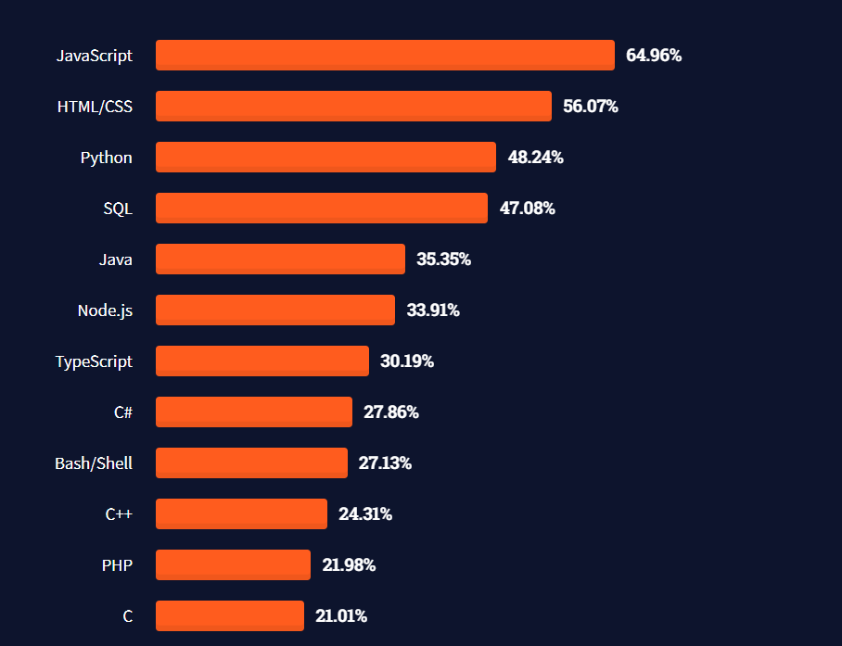

Where is JavaScript used?

JavaScript is primarily used in web browsers to enhance the functionality of websites and web applications.

It's also used on the server-side with Node.js to build scalable network applications.

JavaScript can be found in various environments beyond the web, including mobile app development, desktop app development, game development, IoT (Internet of Things), and more.

JavaScript's versatility extends beyond its traditional role in web development. Here's a more detailed elaboration on each point:

**1. Web Browsers:** JavaScript is the language of the web. It runs in web browsers, enabling developers to create dynamic and interactive web pages. With JavaScript, developers can manipulate the DOM, handle user interactions, perform client-side form validation, make AJAX requests to fetch data from servers asynchronously, create animations, and much more. JavaScript frameworks and libraries like React, Angular, and Vue.js further enhance its capabilities for building modern web applications.

**2. Server-Side with Node.js**: Node.js is a runtime environment that allows developers to run JavaScript code on the server-side. This opens up new possibilities for building scalable and high-performance network applications. With Node.js, developers can create web servers, RESTful APIs, real-time chat applications, microservices architectures, and more. Node.js leverages JavaScript's non-blocking I/O model, making it well-suited for handling concurrent connections and I/O-bound tasks.

**3. Mobile App Development:** JavaScript is increasingly used for mobile app development, thanks to frameworks like React Native and Ionic. React Native allows developers to build cross-platform mobile apps using JavaScript and React. It allows for code sharing between iOS and Android platforms while providing a native-like user experience. Ionic, on the other hand, is a framework that allows developers to build hybrid mobile apps using HTML, CSS, and JavaScript, targeting multiple platforms with a single codebase.

**4. Desktop App Development:** JavaScript is used for desktop app development through frameworks like Electron. Electron combines JavaScript, HTML, and CSS to create cross-platform desktop applications. Apps like Slack, Visual Studio Code, and Discord are built using Electron. With Electron, developers can leverage their existing web development skills to build powerful desktop applications that run on Windows, macOS, and Linux.

**5. Game Development:** JavaScript is used for game development with libraries like Phaser.js and game engines like Unity. Phaser.js is a fast and lightweight JavaScript game framework that allows developers to create 2D games for the web. Unity, on the other hand, is a popular game engine that supports JavaScript (via UnityScript) alongside other programming languages like C# and Boo. With Unity, developers can create games for various platforms, including desktop, mobile, and console.

**6. Internet of Things (IoT):** JavaScript is also making inroads into IoT development. Platforms like Johnny-Five and Espruino enable developers to program microcontrollers and embedded devices using JavaScript. With Johnny-Five, developers can interact with hardware components like sensors, motors, and LEDs using a JavaScript API. Espruino provides a JavaScript interpreter that runs directly on microcontrollers, allowing for rapid prototyping and development of IoT applications.

In summary, JavaScript's versatility allows it to be used in a wide range of environments beyond web browsers, including server-side development, mobile app development, desktop app development, game development, and IoT. This ubiquity makes JavaScript a valuable and in-demand skill for developers across various domains.

How is JavaScript used?

Introducing JavaScript in HTML is typically done by including `<script>` tags within the HTML document. Here's how you can do it:

**1. Inline JavaScript:**

   You can include JavaScript directly within the HTML document using the `<script>` tag. Place the `<script>` tag inside the `<head>` or `<body>` section of your HTML document.

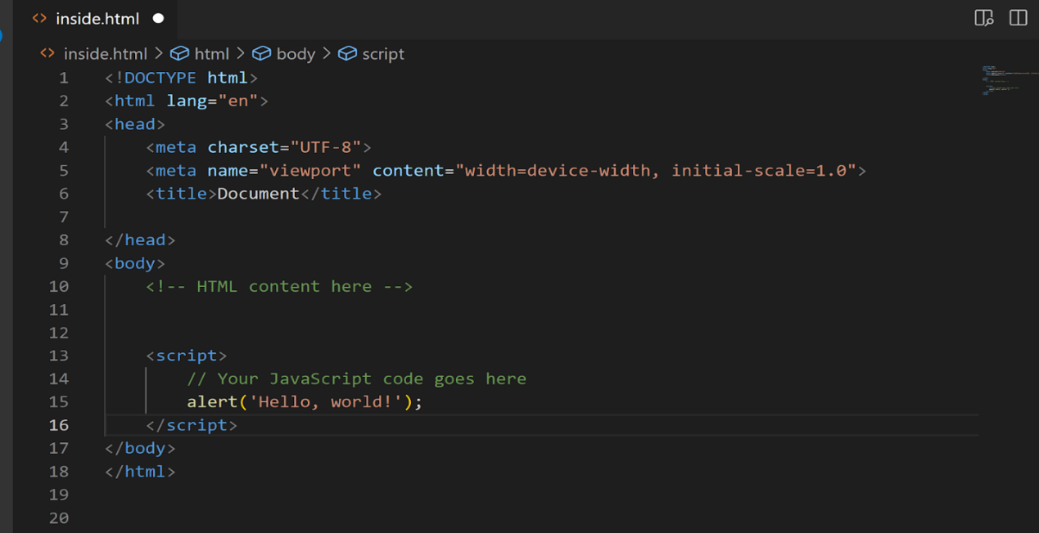

**2. External JavaScript File:**

   Alternatively, you can create a separate JavaScript file with a `.js` extension and include it in your HTML document using the `<script>` tag's `src` attribute.

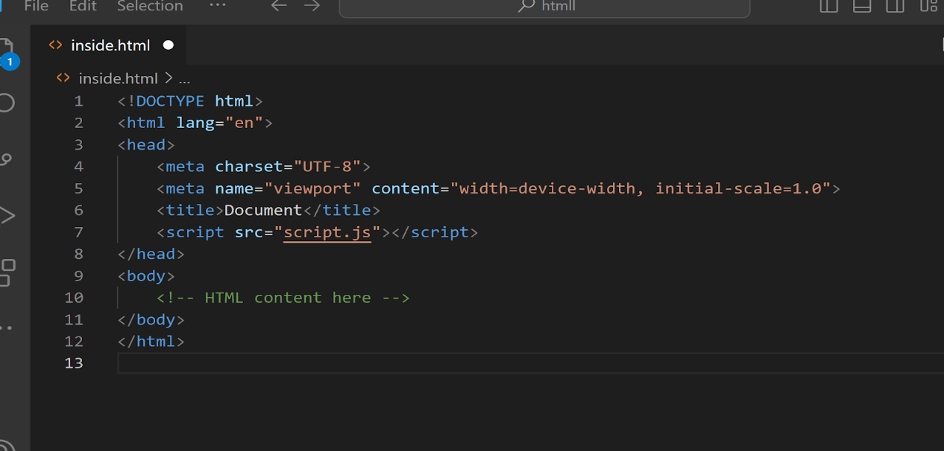

**3. Best Practices:**

   - Place `<script>` tags at the end of the `<body>` section to ensure that HTML content is loaded before JavaScript execution.

   - Use external JavaScript files for better code organization and maintainability.

   - Ensure that your JavaScript code is placed within appropriate HTML elements or event listeners to trigger actions at the desired time.With these methods, you can easily introduce JavaScript into your HTML documents to add interactivity and dynamic behavior to your web pages.